It is named after the edelweiss, a white flower found high in the Alpine hills. It is a protected flower in Austria, Germany and France and therefore illegal to pick. It usually grows in inaccessible places, which is why it is associated in many countries of the alpine region with mountaineering. Its white colour is considered a symbol of purity, and holds a Latin as well as Greek name, floarea reginei (Queen's flower).

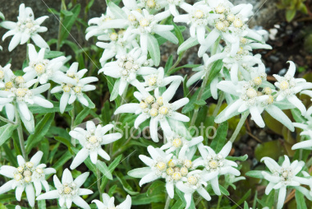

Edelweiss:
Gnani mine

Every morning you greet me
Small and white, clean and bright
You look happy to meet me
Blossom of snow may you bloom and grow
Bloom and grow forever
Edelweiss, Edelweiss
Bless my homeland forever

"May the Lord, mighty God,
bless, preserve you and keep you.
Give you peace, perfect peace,
courage in every endeavor.
Lift up your eyes and see His face,
and His grace forever.
May the Lord, mighty God,
bless, preserve you and keep you!"

Lyrics below by shuddha: Song sung by Ida, Ilah and shuddha for the Gnani Dec 5, 2008.

Gnani mine, Gnani mine
Every moment You be with me
Pure and bright, Eternal Light
Blessed is this home within me

Blossoms of bliss may bloom and grow
Bloom and grow for ever more
Vidhi thine, surrender mine
May it Be, the One, for all.

Long may You live to bless the world
Free this world for ever Lord
Gnani Mine Gnani Mine
You and I are One within…

Let me ‘see’ You in all I meet,
Share this ‘vision’ of Your love
Flawless One, Flawless One,
Let me ‘see’ the flaws within


Click on the Lamp Within above…

